 

**Project Initialization and Planning Phase**

|  |  |
| --- | --- |
| Date | 8 July 2024 |
| Team ID | SWTID1720162737 |
| Project Name | Predicting Compressive Strength of Concrete Using Machine Learning |
| Maximum Marks | 3 Marks |

**Define Problem Statements (Customer Problem Statement Template):**

The construction industry faces challenges in accurately predicting the compressive strength of concrete, which is crucial for ensuring structural integrity and optimizing mix designs. Traditional methods often fall short due to their inability to consider various influencing factors such as mix proportions, curing conditions, and the age of the concrete. This results in potential safety risks, inefficient resource usage, and increased project costs. Machine learning presents a promising solution by leveraging these diverse factors to develop a predictive model. Our project aims to create such a model, assisting engineers and construction professionals in making accurate strength estimations, optimizing concrete mix designs, and enhancing the overall safety and efficiency of construction projects.

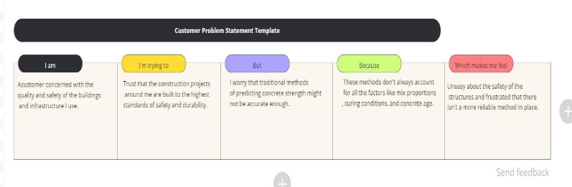

|  |  |  |  |  |  |
| --- | --- | --- | --- | --- | --- |
| **Problem**  **Statement**  **(PS)** | **I am (Customer)** | **I’m trying to** | **But** | **Because** | **Which makes me feel** |
| PS-1 | A customer concerned with the quality and safety of the buildings and infrastructure I use. | Trust that the construction projects around me are built to the highest standards of safety and durability. | I worry that traditional methods of predicting concrete strength might not be accurate enough. | These methods don't always account for all the factors like mix proportions, curing conditions, and concrete age. | Uneasy about the safety of the structures and frustrated that there isn't a more reliable method in place. |
| PS-2 | An engineer responsible for ensuring the structural integrity of construction projects. | Accurately predict the compressive strength of concrete to optimize mix designs and ensure the safety and durability of the structures I work on. | Traditional methods of predicting concrete strength are often slow, costly, and sometimes inaccurate. | These methods do not adequately consider various influencing factors such as mix proportions, curing conditions, and the age of the concrete. | Concerned about potential safety risks, frustrated with inefficiencies, and eager for a more reliable and efficient solution. |